**WEB APPLICATION DEVELOPMENT LAB**

**TASK LAB-DAY 2**

**05-12-2024**

Eshwar Deshmukh Chavan

HU22CSEN0100999

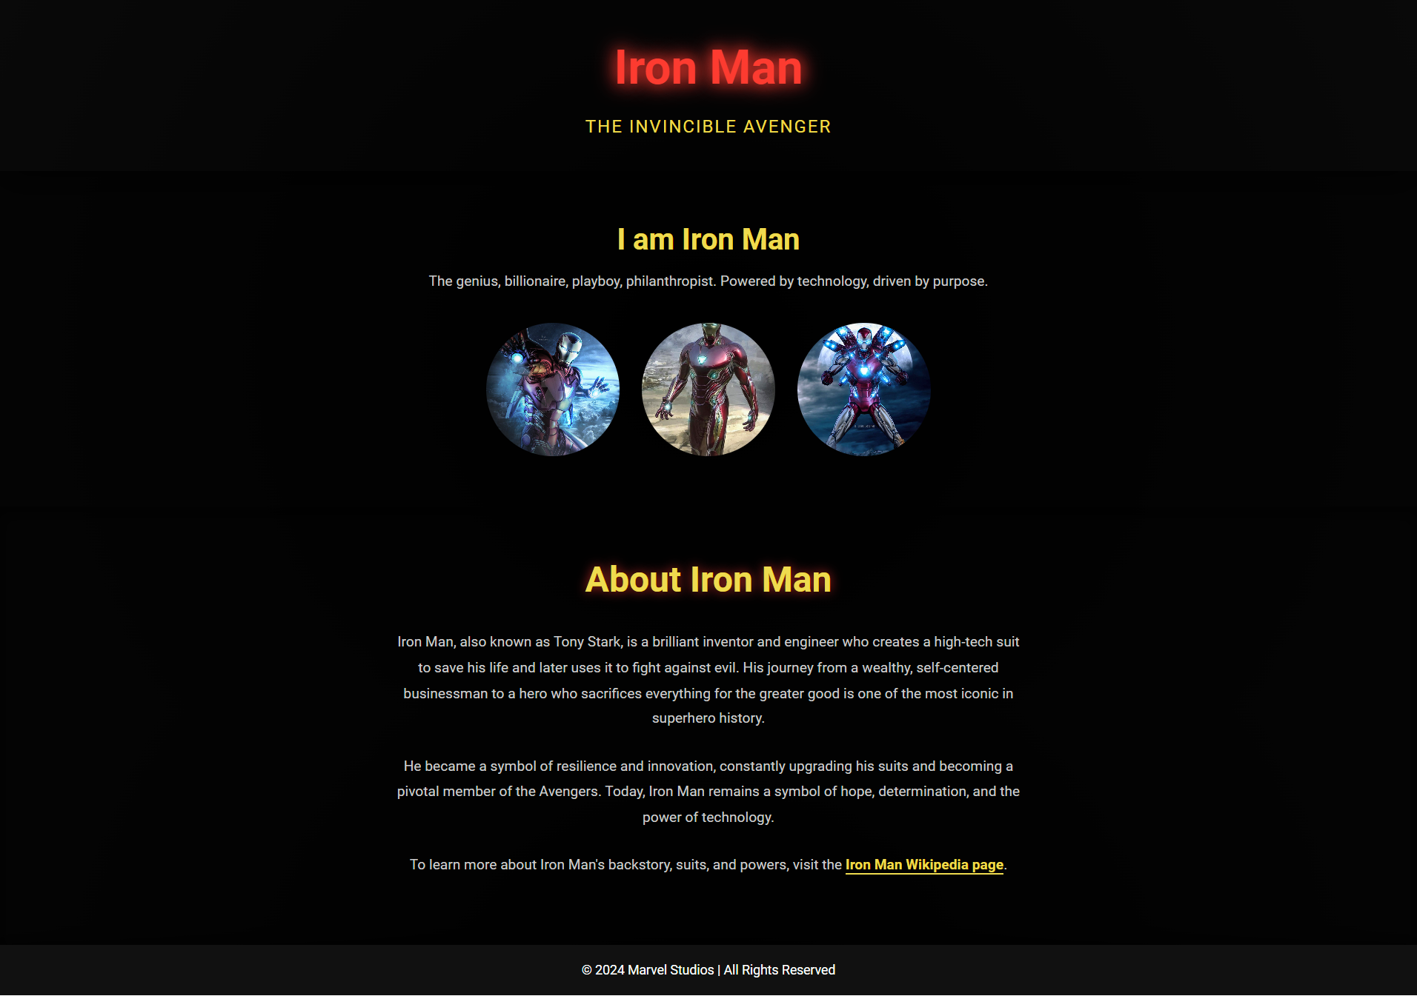

HTML CODE:

<!DOCTYPE html>

<html lang="en">

<head>

<meta charset="UTF-8">

<meta name="viewport" content="width=device-width, initial-scale=1.0">

<title>Iron Man - Marvel Superhero</title>

<link rel="stylesheet" href="style.css">

</head>

<body>

<!-- Header Section -->

<header>

<div class="logo">

<h1>Iron Man</h1>

<p>The Invincible Avenger</p>

</div>

</header>

<!-- Hero Section -->

<section id="hero">

<div class="hero-content">

<h2>"I am Iron Man"</h2>

<p>The genius, billionaire, playboy, philanthropist. Powered by technology, driven by purpose.</p>

<a href="#about" class="cta-btn">Learn More</a>

</div>

</section>

<!-- Iron Man Moments Section (New) -->

<section id="iron-man-moments">

<div class="section-title">

<h2>I am Iron Man </h2>

<p>The genius, billionaire, playboy, philanthropist. Powered by technology, driven by purpose.</p>

</div>

<div class="hero-images">

<a href="https://marvelcinematicuniverse.fandom.com/wiki/Iron_Man" target="_blank">

<img src="iron-man4.jpg" alt="Iron Man Pose 1" class="hero-img">

</a>

<a href="https://en.wikipedia.org/wiki/Iron_Man" target="_blank">

<img src="iron-man.jpg" alt="Iron Man Pose 2" class="hero-img">

</a>

<a href="https://www.marvel.com/characters/iron-man-tony-stark" target="_blank">

<img src="iron-man3.jpg" alt="Iron Man Action Shot" class="hero-img">

</a>

</div>

</section>

<!-- About Iron Man -->

<section id="about">

<div class="about-container">

<h2>About Iron Man</h2>

<p>Iron Man, also known as Tony Stark, is a brilliant inventor and engineer who creates a high-tech suit to save his life and later uses it to fight against evil. His journey from a wealthy, self-centered businessman to a hero who sacrifices everything for the greater good is one of the most iconic in superhero history.</p>

<p>He became a symbol of resilience and innovation, constantly upgrading his suits and becoming a pivotal member of the Avengers. Today, Iron Man remains a symbol of hope, determination, and the power of technology.</p>

<p>To learn more about Iron Man's backstory, suits, and powers, visit the <a href="https://en.wikipedia.org/wiki/Iron_Man" target="_blank" class="external-link">Iron Man Wikipedia page</a>.</p>

</div>

</section>

<!-- Footer -->

<footer>

<p>© 2024 Marvel Studios | All Rights Reserved</p>

</footer>

</body>

</html>

CSS CODE:

/* Global Styles */

* {

margin: 0;

padding: 0;

box-sizing: border-box;

}

body {

font-family: 'Roboto', sans-serif;

color: #fff;

background: radial-gradient(circle at center, #000000, #2c2c2c);

overflow-x: hidden;

font-size: 1.1rem;

line-height: 1.6;

display: flex;

flex-direction: column;

height: 100vh;

}

/* Header Section */

header {

text-align: center;

padding: 40px 0;

background: rgba(0, 0, 0, 0.8);

box-shadow: 0px 10px 50px rgba(0, 0, 0, 0.7);

position: relative;

z-index: 10;

}

header h1 {

font-size: 4rem;

color: #ff3b30; /* Iron Man red */

text-shadow: 0 0 20px rgba(255, 59, 48, 0.8), 0 0 30px rgba(255, 59, 48, 0.9);

}

header p {

font-size: 1.5rem;

color: #f0db4f; /* Yellow */

letter-spacing: 2px;

text-transform: uppercase;

margin-top: 10px;

animation: pulse 2s infinite alternate;

}

@keyframes pulse {

0% {

transform: scale(1);

}

100% {

transform: scale(1.05);

}

}

/* Hero Section */

#hero {

position: relative;

height: 100vh;

background: url('iron-man-hero-bg.jpg') no-repeat center center fixed;

background-size: cover;

text-align: center;

display: flex;

flex-direction: column;

justify-content: center;

align-items: center;

color: #fff;

overflow: hidden;

animation: fadeIn 3s ease;

}

@keyframes fadeIn {

0% {

opacity: 0;

}

100% {

opacity: 1;

}

}

.hero-content {

z-index: 10;

margin-bottom: 30px;

}

.hero-content h2 {

font-size: 4rem;

color: #ff3b30;

text-shadow: 0 0 30px rgba(255, 59, 48, 0.8), 0 0 50px rgba(255, 59, 48, 1);

margin-bottom: 20px;

}

.hero-content p {

font-size: 1.5rem;

color: #fff;

font-weight: 300;

margin-bottom: 30px;

max-width: 700px;

margin-left: auto;

margin-right: auto;

}

.cta-btn {

background: rgba(240, 219, 79, 0.9);

color: #333;

padding: 16px 35px;

font-size: 1.4rem;

border-radius: 30px;

text-decoration: none;

transition: background-color 0.3s, transform 0.3s;

box-shadow: 0 5px 20px rgba(240, 219, 79, 0.4);

}

.cta-btn:hover {

background-color: #e0c544;

transform: scale(1.1);

box-shadow: 0 0 30px rgba(240, 219, 79, 0.8);

}

/* Iron Man Moments Section */

#iron-man-moments {

padding: 60px 20px;

background: rgba(0, 0, 0, 0.9);

text-align: center;

}

#iron-man-moments .section-title h2 {

font-size: 2.5rem;

color: #f0db4f;

margin-bottom: 10px;

}

#iron-man-moments .section-title p {

font-size: 1.2rem;

color: #ccc;

margin-bottom: 40px;

}

/* Hero Images */

.hero-images {

display: flex;

justify-content: center;

gap: 30px;

flex-wrap: wrap;

}

.hero-images a {

display: inline-block;

transition: transform 0.3s ease, box-shadow 0.3s ease;

}

.hero-img {

width: 180px;

height: 180px;

border-radius: 50%; /* Circular shape */

object-fit: cover;

box-shadow: 0px 10px 40px rgba(0, 0, 0, 0.7);

transition: transform 0.3s ease, box-shadow 0.3s ease;

}

.hero-img:hover {

transform: scale(1.1);

box-shadow: 0 0 25px rgba(255, 59, 48, 0.9);

}

/* About Section */

#about {

padding: 60px 20px;

background: rgba(0, 0, 0, 0.9);

color: #ccc;

text-align: center;

box-shadow: inset 0px 10px 20px rgba(0, 0, 0, 0.6);

position: relative;

}

#about h2 {

font-size: 3rem;

color: #f0db4f;

margin-bottom: 30px;

text-shadow: 0px 0px 15px rgba(255, 59, 48, 0.7);

}

#about p {

font-size: 1.2rem;

line-height: 1.8;

max-width: 850px;

margin: 0 auto 30px;

}

.external-link {

color: #f0db4f;

font-weight: bold;

text-decoration: none;

border-bottom: 2px solid #f0db4f;

transition: color 0.3s ease, border-bottom 0.3s ease;

}

.external-link:hover {

color: #ff3b30;

border-bottom: 2px solid #ff3b30;

}

/* Footer */

footer {

padding: 20px 10px;

background-color: #111;

color: #fff;

text-align: center;

box-shadow: 0 -5px 20px rgba(0, 0, 0, 0.6);

}